Name : Vijay M

Reg. No. : 731621106058

College : KSRIET

DAY4 LEARNING

JOIN

1. JOIN =

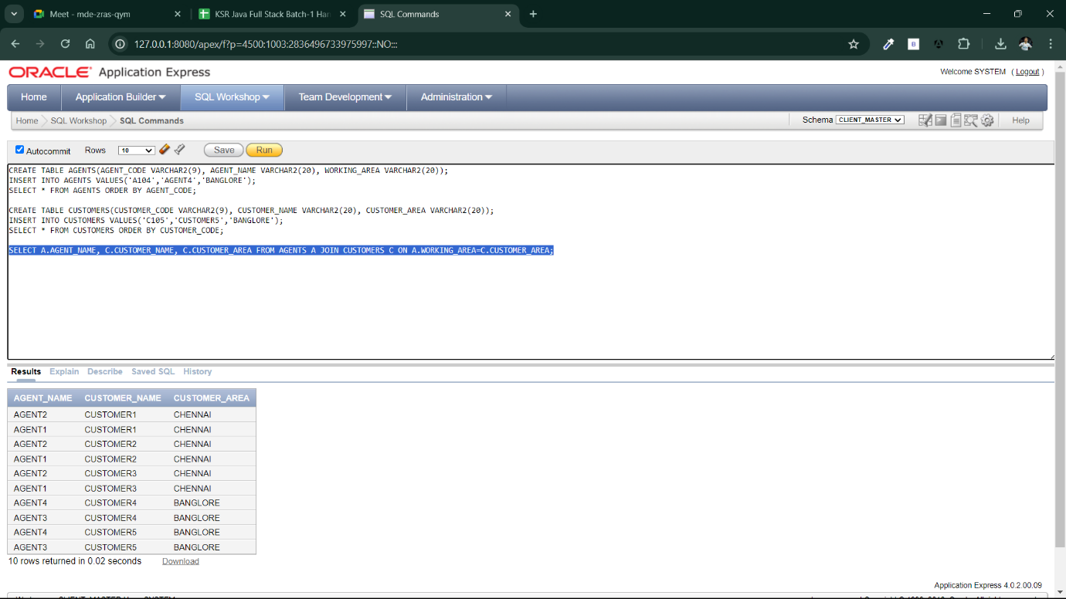

1. 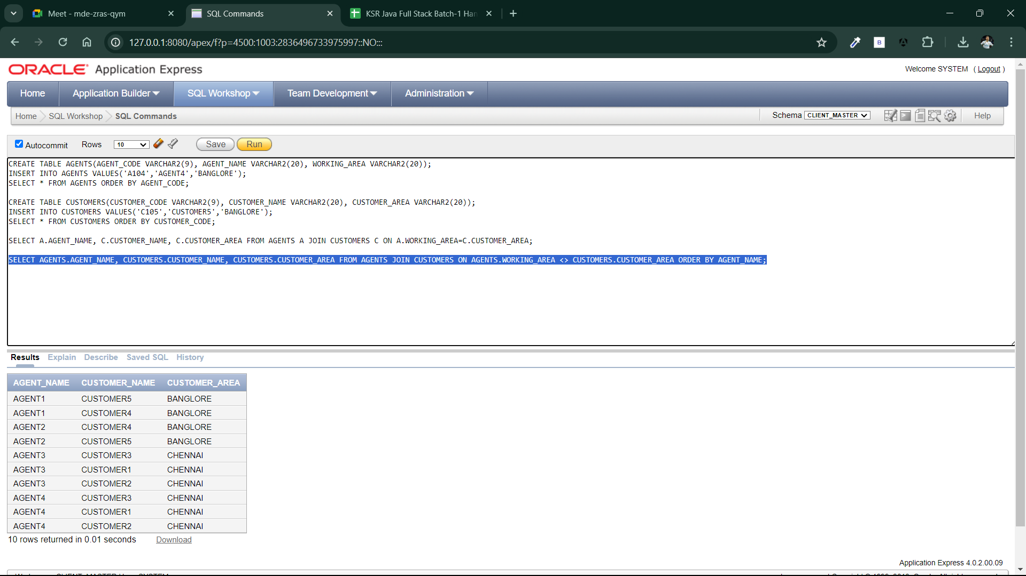JOIN <> (NOT EQUAL)
2. LEFT OUTER JOIN

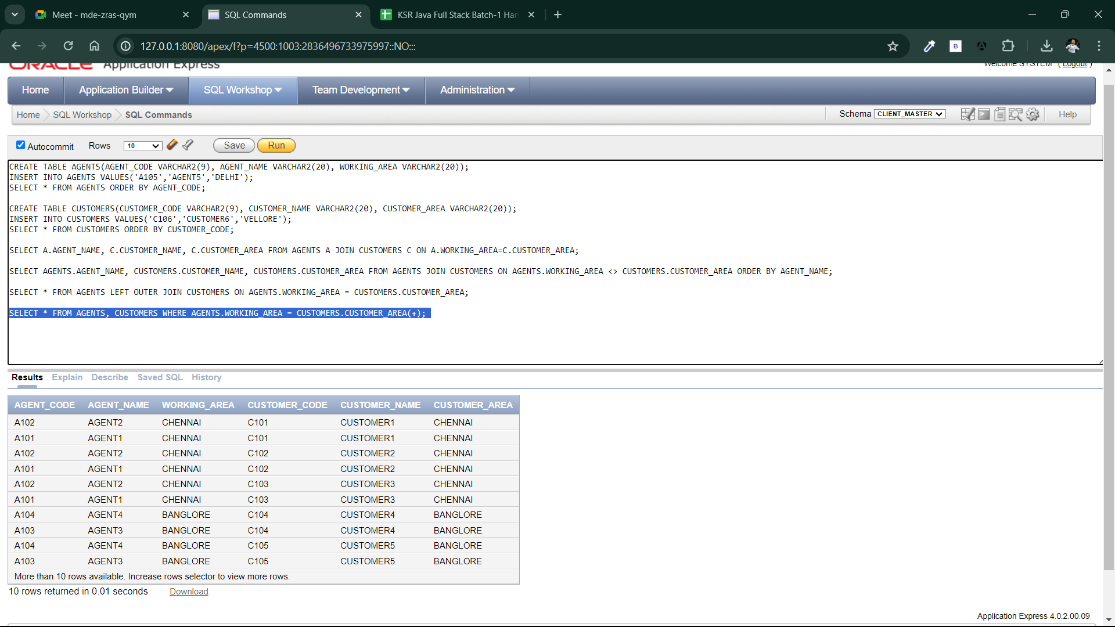

1. RIGHT OUTER JOIN

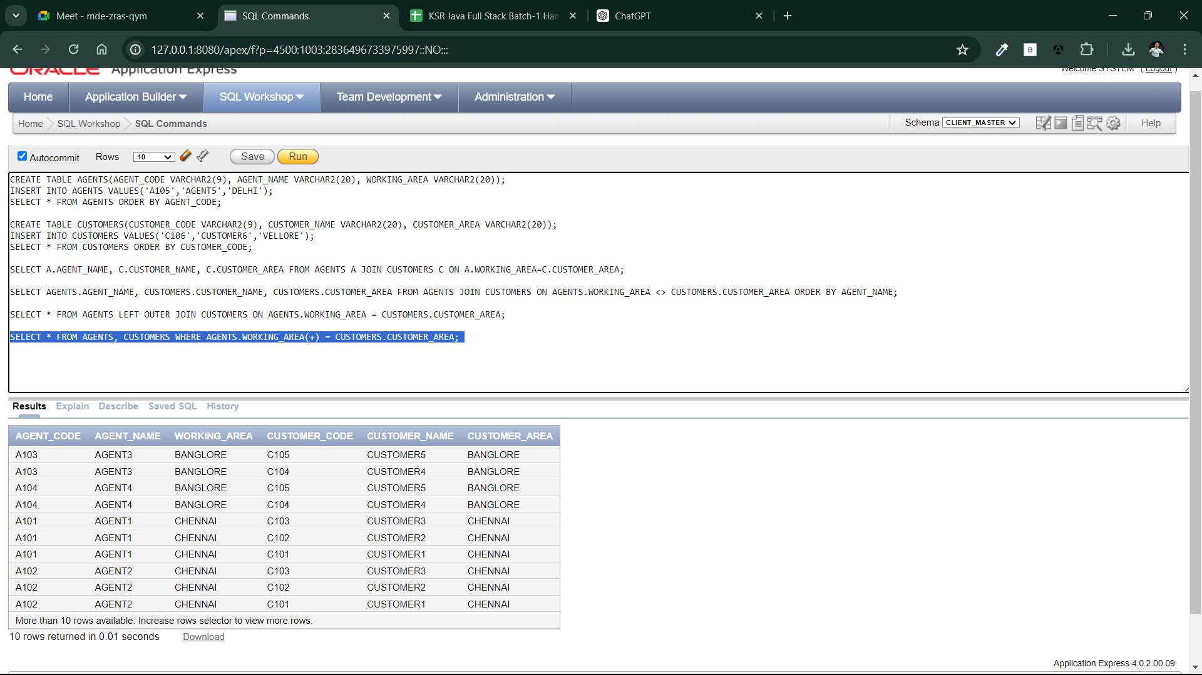

1. 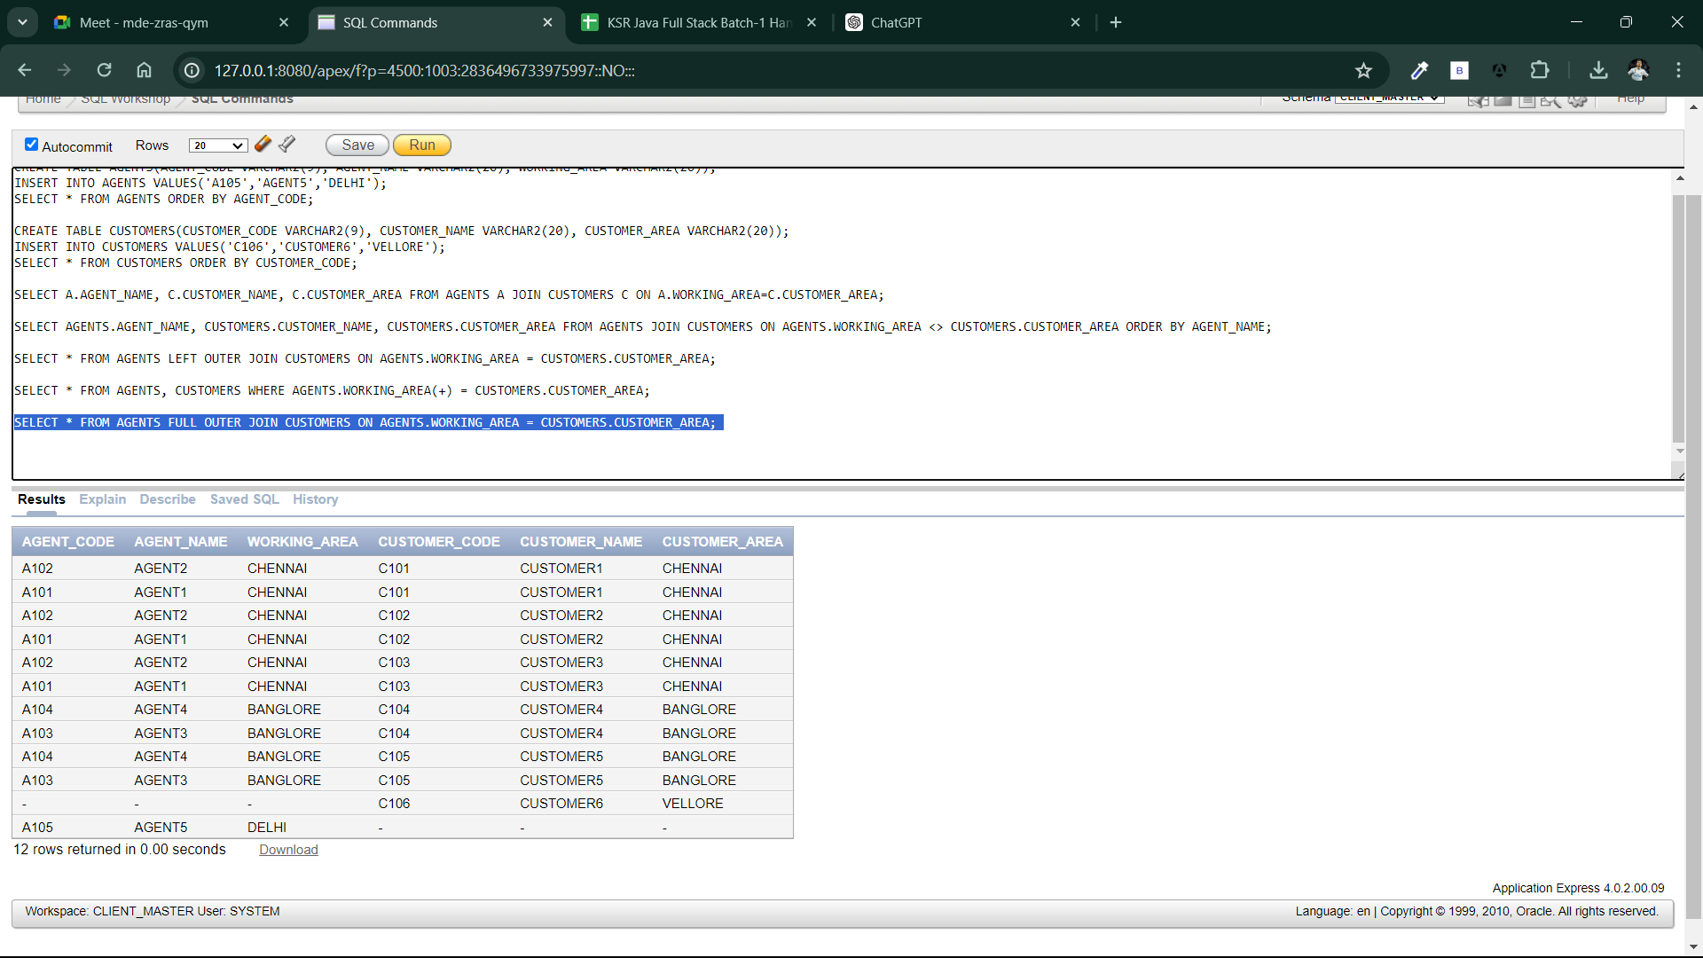FULL JOIN
2. 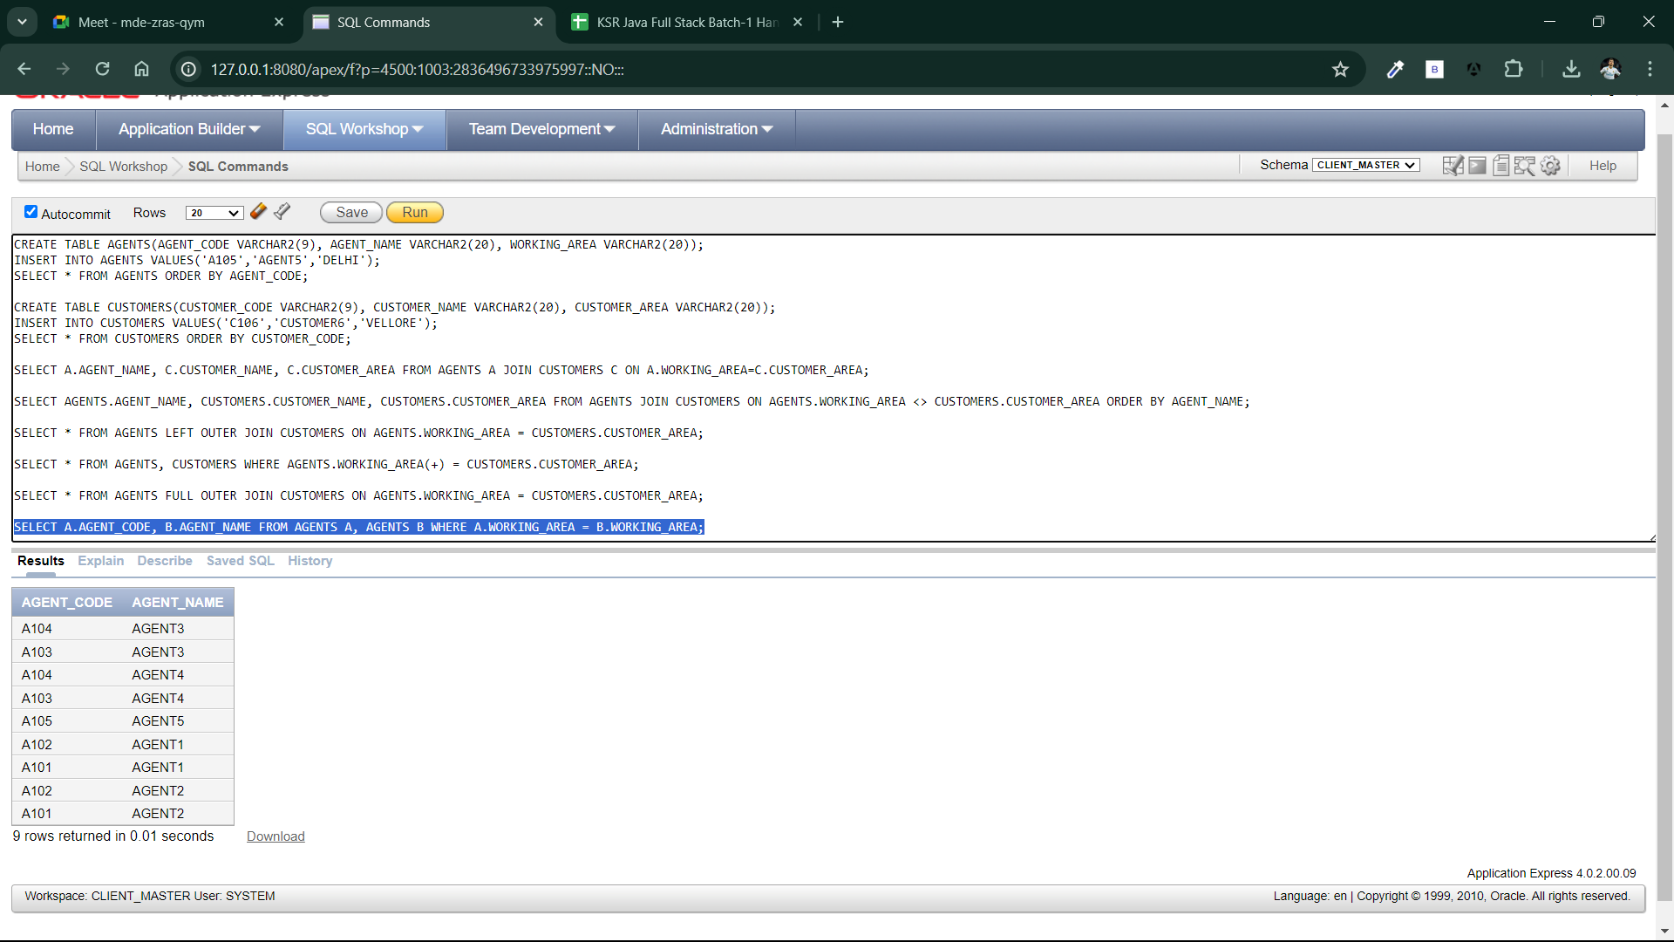SELF JOIN
3. CROSS JOIN

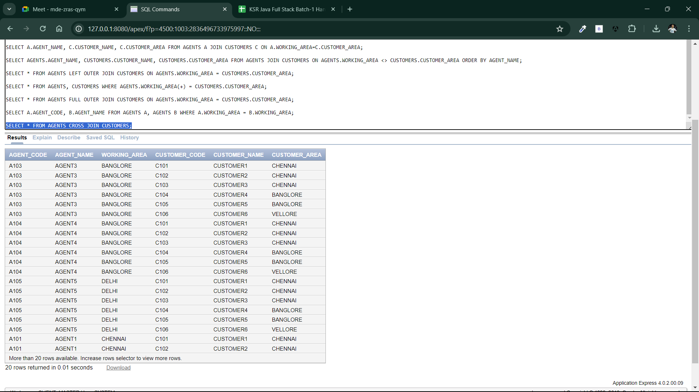

1. NATURAL JOIN

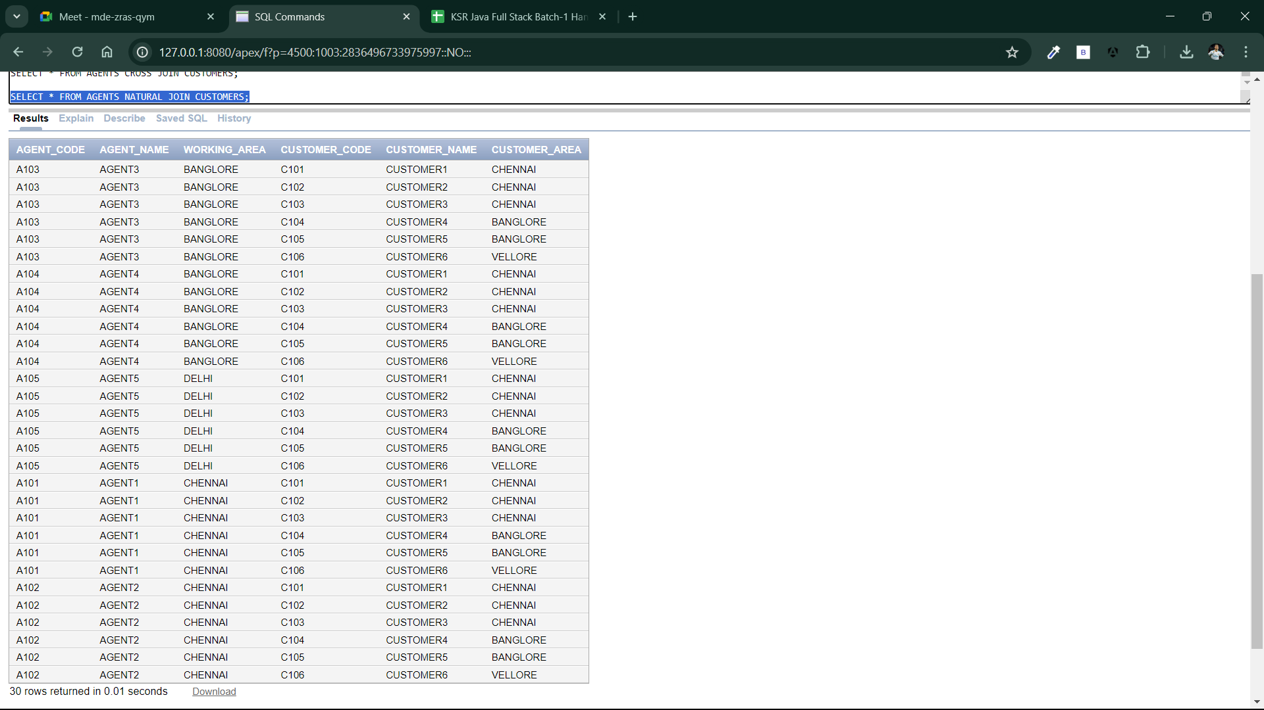

**SUB QUERIES**

